Lorenzo Fuga

DSEM 100, C1

Prof. Soderholm

20 September 2019.

Paper 1, Final.

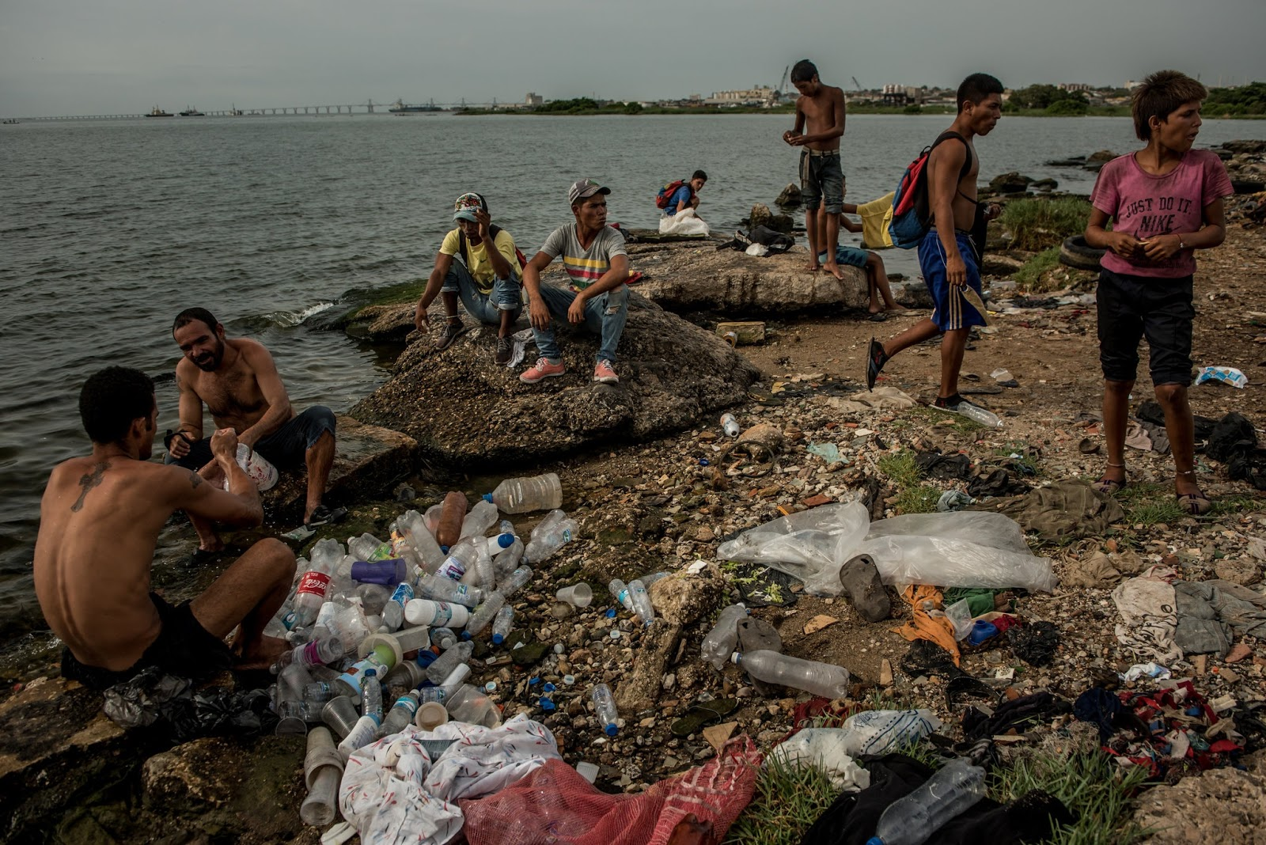Meredith Kohut. Venezuelans washing recyclable plastic they have scavenged at Maracaibo Lake. Published in *The New York Times* on May 2019.

Dear World Press Photo Committee,

I nominate Meredith Kohut for the World Press Photo Prize in contemporary issues for her photograph of poverty in Venezuela. Kohut's photograph captures the essence of the actual situation that Venezuela is going through right now.

The tone of this photograph is dark. By defining it as dark scaled, it is perceived to be a variation of dark colors such as the color of the water that instead of being blue it is black, or also all the objects look darker than their standard color like the dirty plastic. It represents the mood of the struggles the community shares. Another vital factor in this photograph is the weather; the photograph shows a rainy or cloudy day.The form exemplifies the shadows and highlights in the photo presented as moody and negativity. There is a minimum source of light considering the weather causing this; therefore, the tint on each person is evenly balanced. This photo represents nine civilians, all of which include eight boys and one girl. As these people in the photographs show us, right now cloth is a luxury in the most deprived areas in Venezuela. The kids on Kahout's photo are wearing a minimal amount of cloth, and just a few of them wear shoes.The recycled plastic on the ground consists of mainly large-sized water bottles which they are most likely going to fill up with dirty water. These bottles show the only source of water that the community has. Many times, people go days without it. Besides the recyclable items located on the ground, the photo also depicts different cloth pieces scattered everywhere; even a rubber tire close to the background. The people look unsanitary. The vantage point represents the side view of people washing recyclable items and a bridge in the horizon. Two people are communicating, and the other people are just in solitude. There are also some green grass patches and some places without them.

Moreover, Kahout’s photograph is very compelling and deserves  attention and the prize. It should win because it is a visual interpretation of the complete shift in Venezuela today. It shows the real determination of the community trying to survive off the minimal amount of resources provided. The visual tone of the water represents a sad, dreary day because there are no waves and the color of the water is dirty. The photographer has much knowledge about this subject, considering the location where the photographer took the photo. In order for her to access this area, they must trust her enough to share their stories and exchange words for understanding the culture and their daily lives. This experience is a risky situation for the photographer to go and take pictures due to the circumstances of the entire country. The fact that she dares to to go to a dangerous, violent, and civil war area emphasizes her bravery into sharing with the world what they are going through. The emotional tone of the photograph represents sadness and a depressed environment of what the population is going through. There was once clean liquid inside of those water bottles, and now they will be full of disgusting water.

The news this photo represents is about the extreme poverty and living conditions that many Venezuelan are currently going through and it is impressing how it is an extreme example of the social problem because of the government causing it. As Anatoly Kurmanaev describes in his article published in *The New York Times*,“Venezuela has the world's largest proven oil reserves…but it has fallen faster in the past year”(Kurmanaev). This situation is a real struggle by the government because of their highest resource falling quickly. A problematic like this one is also an example of them not taking advantage of the resources they have, resulting in the collapsed economy.  Many jobs have caused this result in poverty, for example, “Butchers have stopped selling meat cuts in favor of offal, fat shavings, and cow hooves, the only animal protein many of their customers can afford”(Kurmanaev), the fact that in a nation people do not have the knowledges or items to do certain basic things is unthinkable.

As a manner of fact, Kohut's photograph nomination is essential; the photo depicts the difficulties that Venezuelans confront every day. They live the consequences of the war in their country.  The photograph shows the primary resources scarcity in the country. It is inconceivable that people have to wash plastics in order to get some water for everybody in the area. According to Kenneth Rodoff, an economics professor at *Harvard University* and former chief economist at the *International Monetary Fund*, “It’s really hard to think of a human tragedy of this scale outside of civil war… this will be a touchstone of disastrous policies for decades to come”(Kurmanaev).

 It is inhuman what they are going through. The citizens do not know how to take care of the animals and also do not have the resources to tame the animals to be good enough to eat properly.  In order for the people outside of Venezuela to thoroughly understand the dramatic issues in this country, they must understand the severity and quality of life these people have.

As has been noted, Kohut's photograph deserves winning World Press Photo of the year, considering the risks in which the photographer has been in order to take it and because it perfectly reflects the issue.

Thank you for your consideration,

Lorenzo Fuga.

Work Cited

Kurmanaev, Anatoly. “Venezuela’s Collapse Is the Worst Outside of War in Decades, Economists Say”. The New York Times, 17 May 2019. <https://www.nytimes.com/2019/05/17/world/americas/venezuela-economy.html>. Accessed 19 Sep. 2019.

Kohut, Meredith. Venezuelans washing recyclable plastic they have scavenged at Maracaibo Lake. 17 May 2019. The New York Times, <https://static01.nyt.com/images/2019/05/12/world/12Venezuela-Econ-06/8d52c05197d940a18fcae5cde184b190-5-superJumbo.jpg?quality=90&auto=webp>. Accessed 19 Sep. 2019.